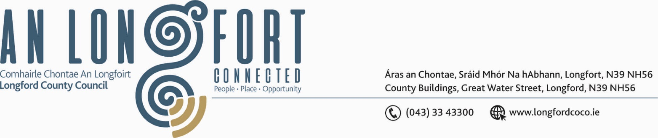

Please note meeting venue – Council Chamber, Aras an Chontae.

BALLYMAHON MUNICIPAL DISTRICT

8th March 2019.

To: Each Member of Ballymahon Municipal District.

Dear Member,

You are requested to attend Meeting of Ballymahon Municipal District to be held in the Council Chamber, Aras on Chontae, on Thursday, 14th March 2019 at
4.30 p.m. to transact business, as set out on the Agenda hereunder.

Yours sincerely,
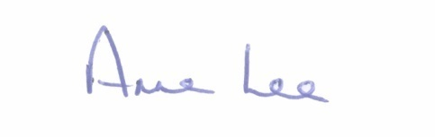

_______________
Anne Lee,
Meetings Administrator.

AGENDA

Prayer before meeting.

1. Confirmation of Minutes of the following Meetings of Ballymahon Municipal District -

- Municipal District Committee Meeting held on the 24th January 2019.
- Municipal District January Meeting held on the 24th January 2019.
- Special Municipal District Meeting held on the 15th February 2019.
copies enclosed.

2. Matters arising from Minutes.

3. Management Report - enclosed.

4. To consider and approve Schedule of Ballymahon Municipal District Works - report to follow.

5. Consideration of applications for funding under the 2019 Community Grant Support Scheme - list enclosed.

6. To consider and approve Special Projects fund.

7. Cemeteries in the Ballymahon MD area - update from Environment Section
-report enclosed.

8. Notices of Motions submitted by Councillors, as listed hereunder –

Councillor Pat O’Toole.

“I call on Longford County Council to provide public lighting on a stretch of the R392 approximately 0.5 Km long from Ballymahon Montessori School to the Longford Bridge at Drynan, Ballymahon.”

“ I call on Longford County Council to consider providing public lighting on the Royal Canal Greenway from Longford Bridge to Brannigan Harbour - an area that is used extensively all year round by cyclists, joggers, and walkers.
The public lighting would greatly enhance it from a safety point of view, particularly during the Winter months.”

“I call on Longford County Council to provide lighting on the pedestrian crossing at St.Matthew's Church, Ballymahon. A similar
pedestrian crossing in Kenagh Village is very well lit with two low level street lights on the poles over the crossing.”

Councillor Paul Ross.

“That a speeding study be undertaken at Ballycloughan and appropriate traffic calming measures be put in place in the interest of public safety.”

“That Longford County Council contacts Irish Rail to request that they extend their car park at Edgeworthstown Station as it is now at capacity every day.”

Councillor Mick Cahill.

“As a number of cars have entered the Canal at Scally's Bridge on L1105 in Abbeyshrule and also a number of Articulated Trucks have got jammed on the bridge, and in the interest of road safety, I request that Longford County Council provides appropriate signage and lighting on Scally's Bridge on L1105 in Abbeyshrule and also to provide signs at both ends of this road to indicate its unsuitability for Articulated Trucks".

"That Longford County Council carries out works on L1098 Road outside the School in Ardagh as the road is in poor condition and, in the interests of road safety, to consider the provision of Traffic Calming measures.”

“That Longford County Council considers doing works on the roundabouts in Edgeworthstown similar to the Dromod roundabout on the N4.”

